Binary Search

1. Binary Search Lower/Upper Bound

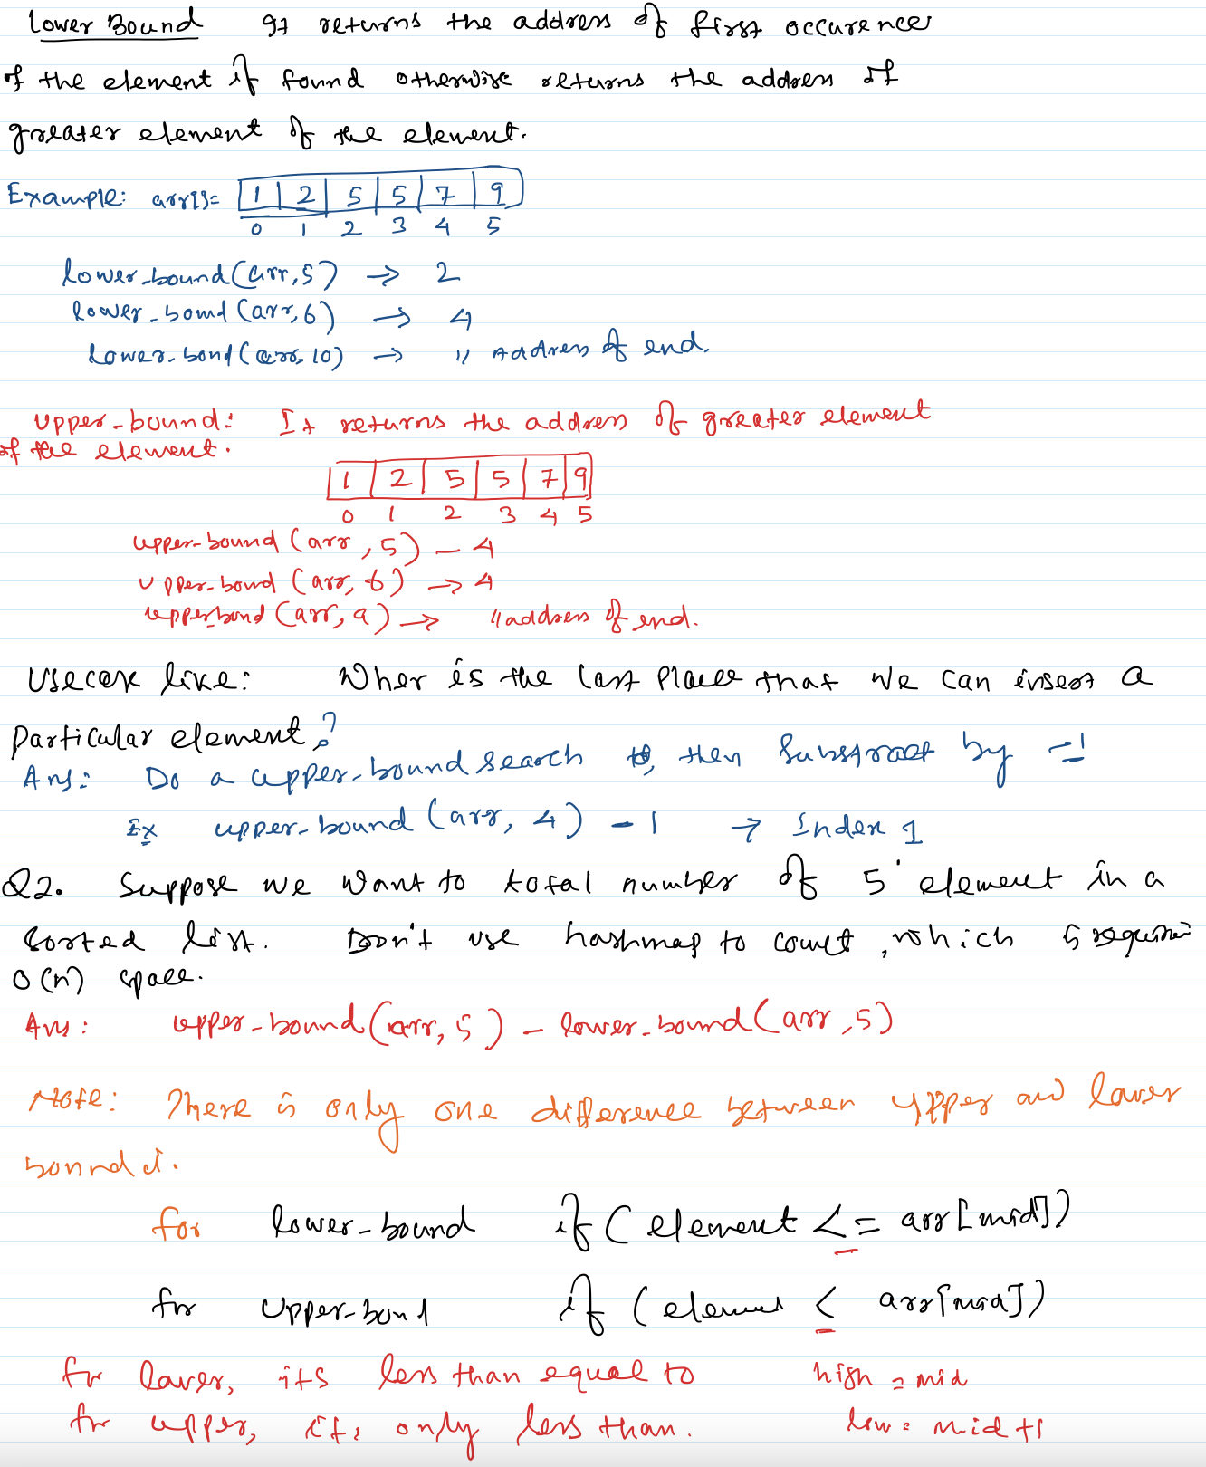

<https://www.youtube.com/watch?v=6-15eccc6ek>

Also refer: <https://www.youtube.com/watch?v=edJ19qIL8WQ>

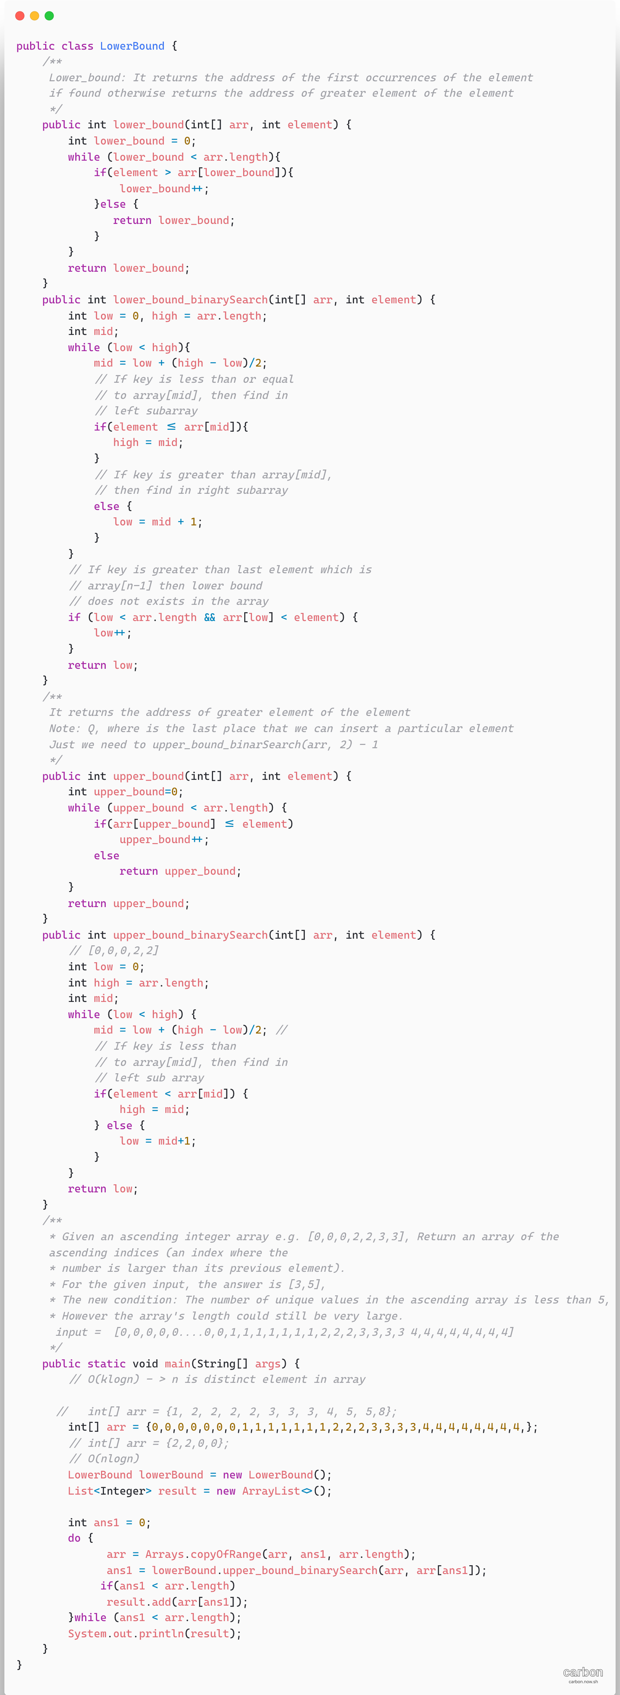

1. [First and last position of element in Sorted Array](https://leetcode.com/problems/find-first-and-last-position-of-element-in-sorted-array/)

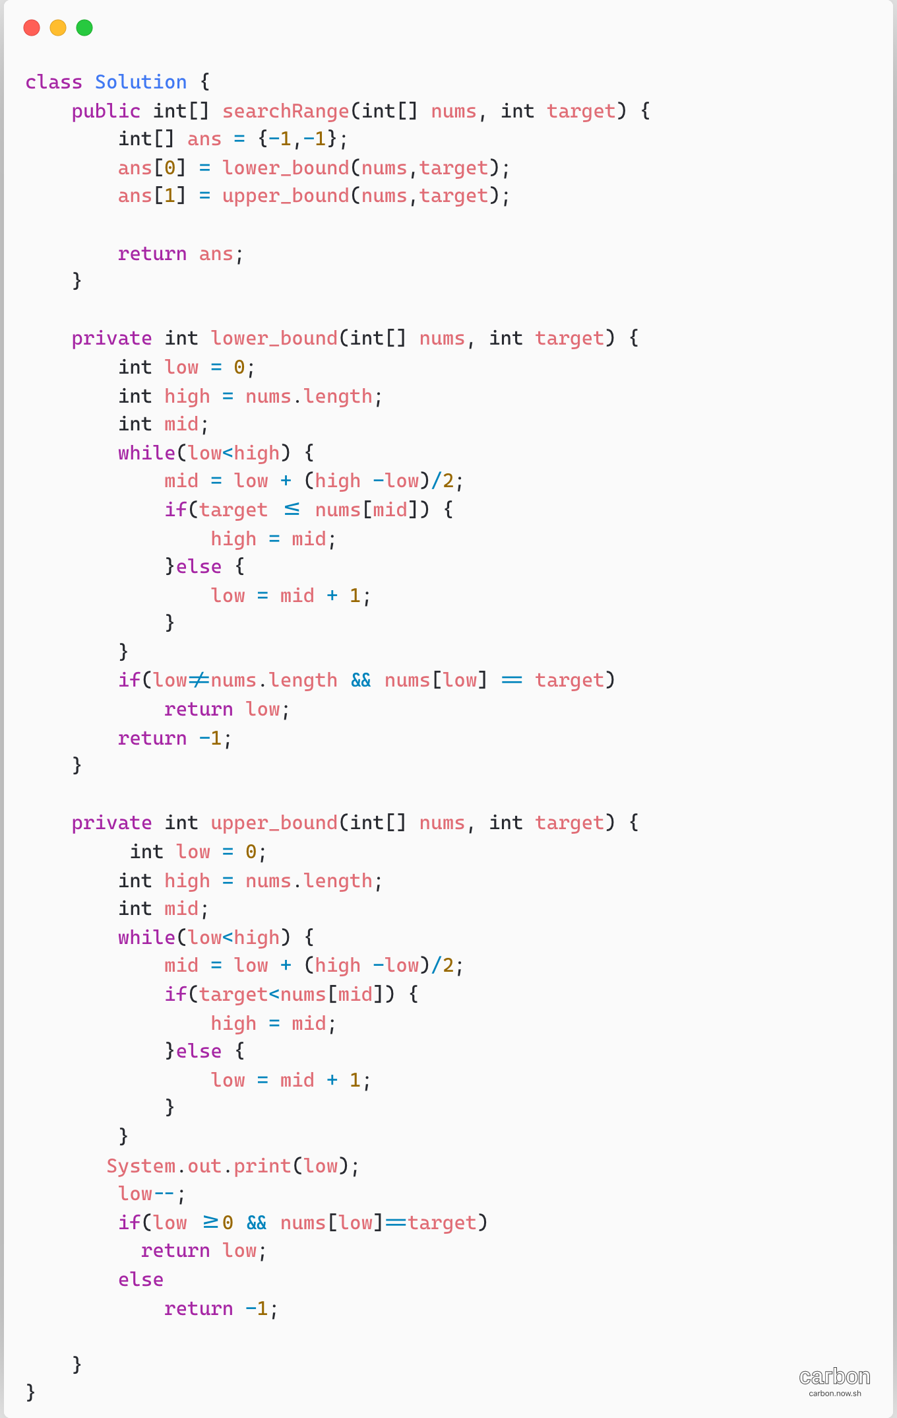

1. **Binary Search**

X – Element to be searched, there are three cases,

1. X == mid return mid
2. X < mid

High = mid -1

1. X > mid

Low = mid+1

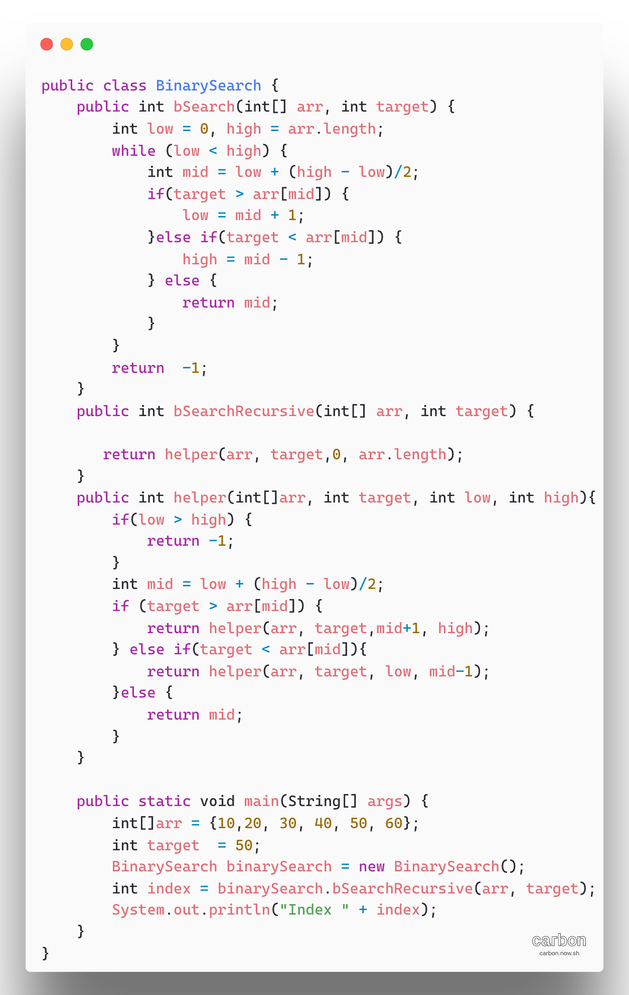

1. **First Occurrence in sorted array**

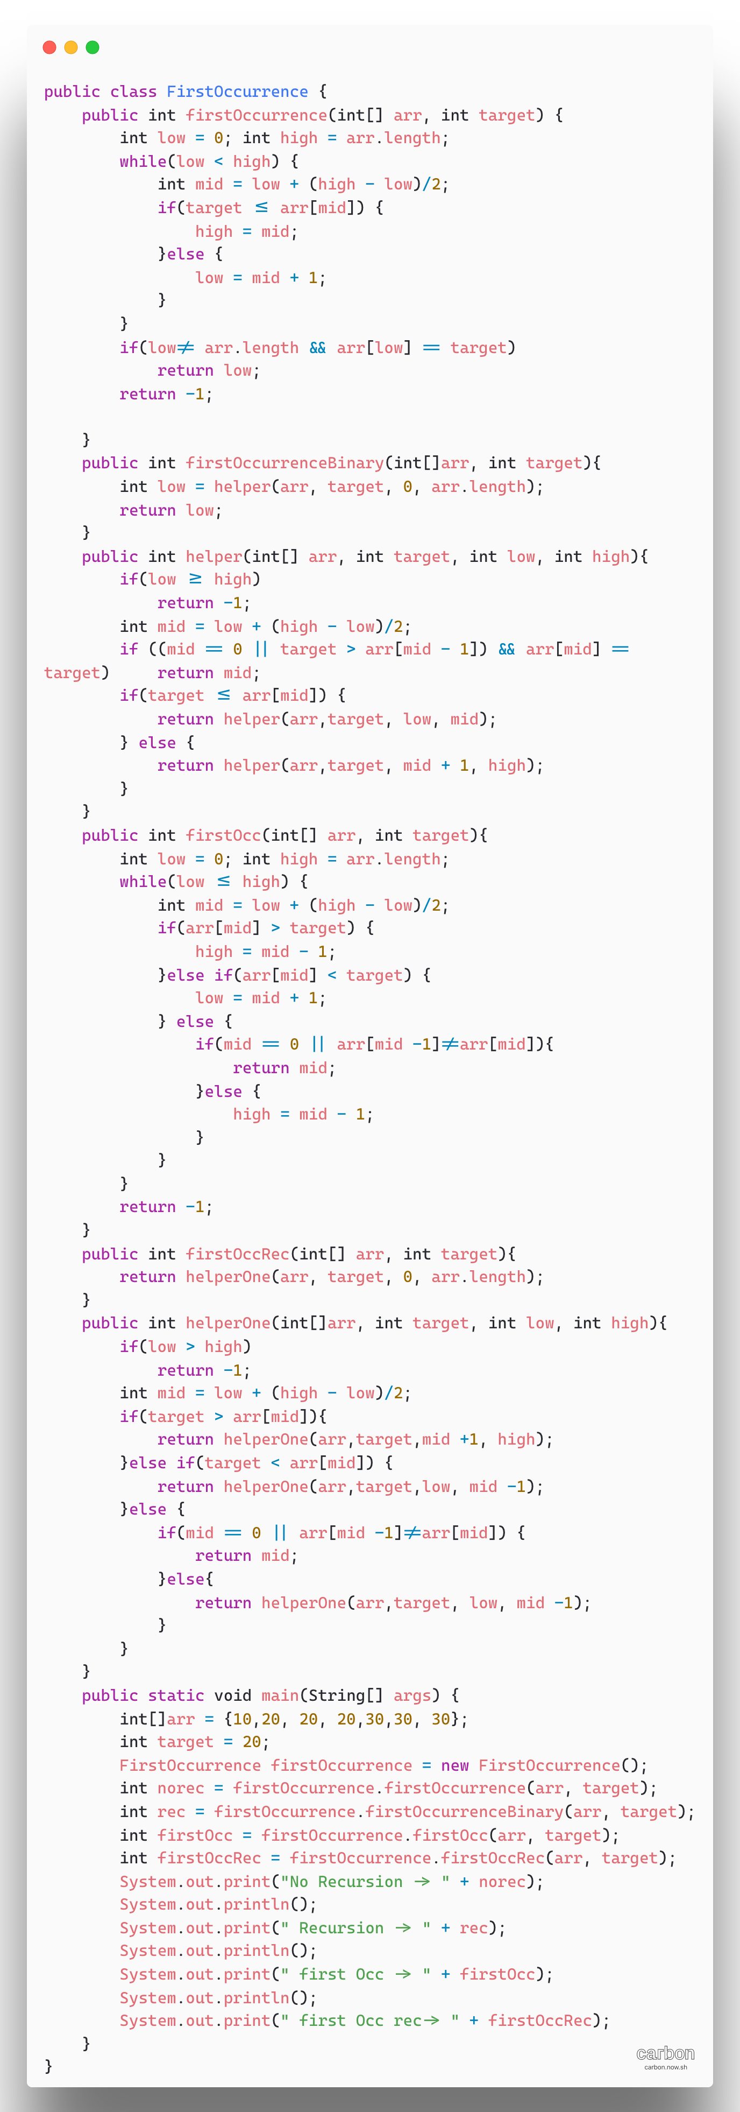

1. **Last Occurrence in sorted Array**

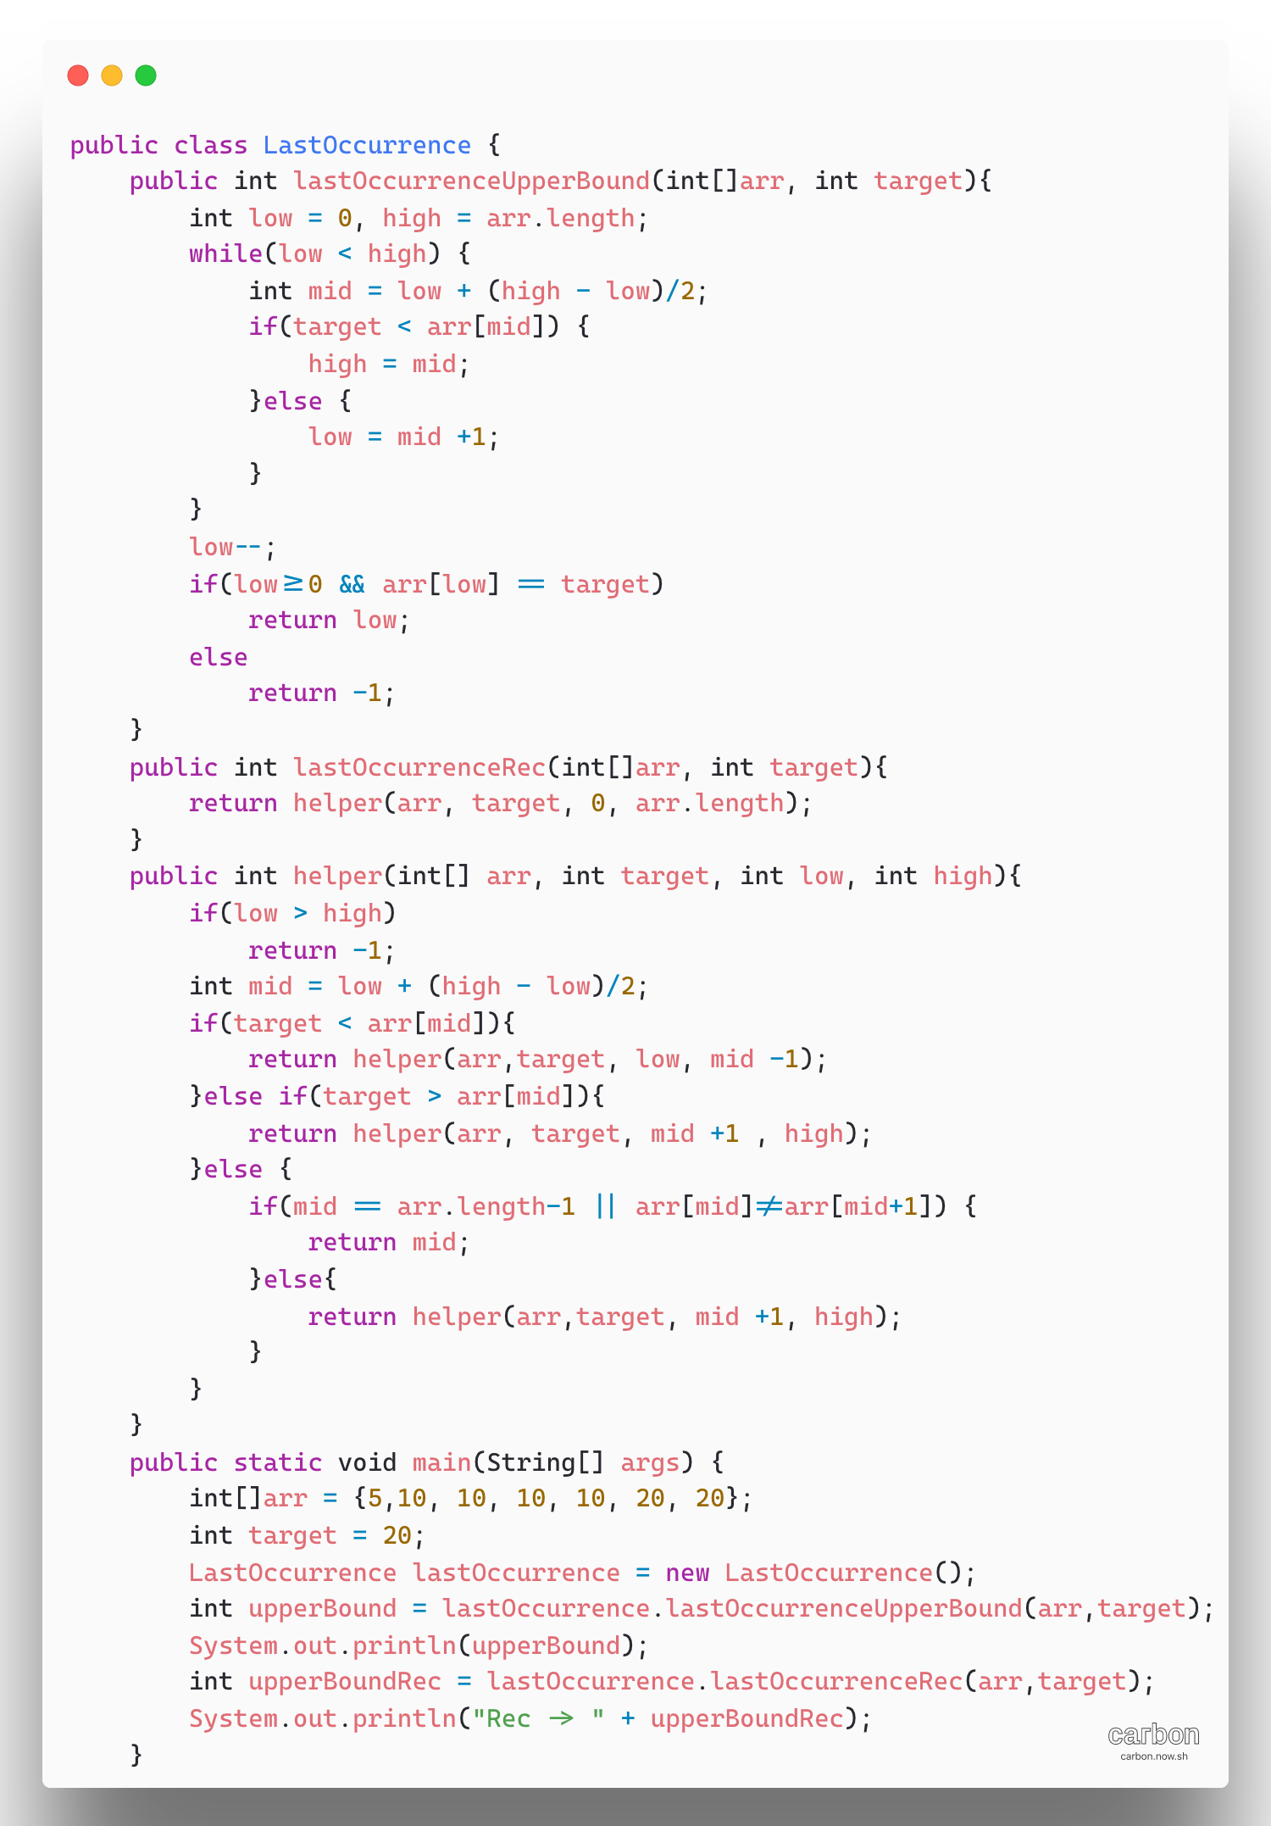

1. **Count1’s InSortedBinary Array**

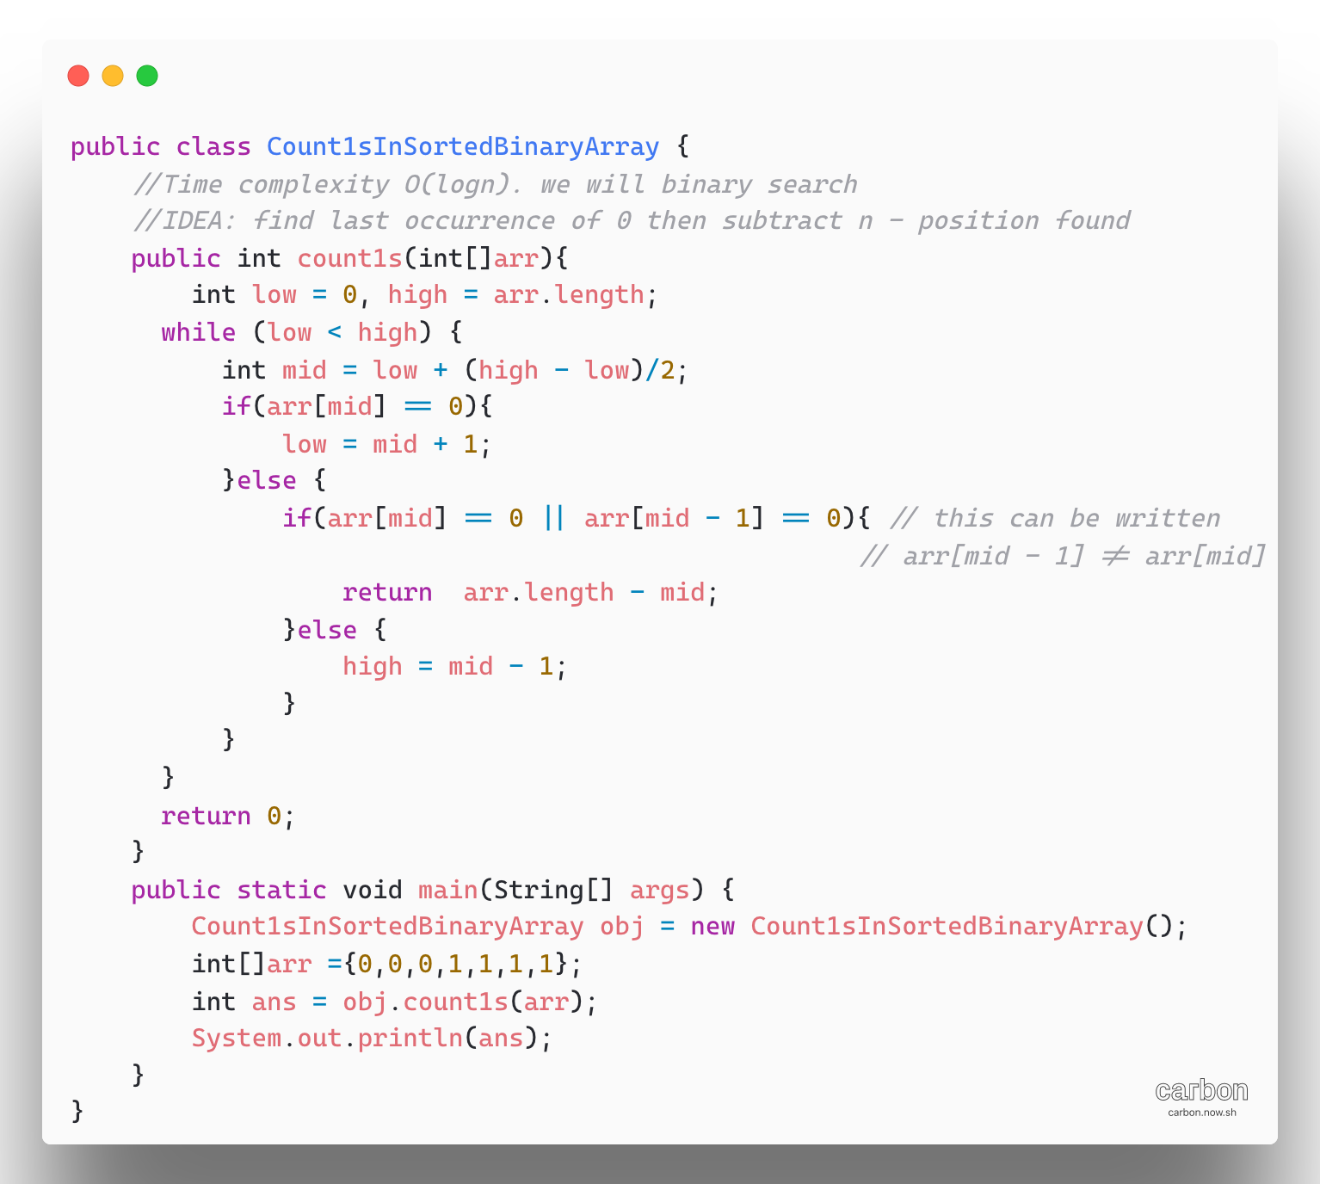

1. Given an integer x, find its square root, if x is not a perfect square, then return floor(√x).

Examples: x = 4

Output = 2

Explanation: The square root of 4 is 2

X = 11

Output = 3, the square root of 11 lies in between 3 and 4 so floor of the square root is 3.

There can be many ways to solve this problem. For example [Babylonian Method](https://www.geeksforgeeks.org/square-root-of-a-perfect-square/) is one way.

Simple Approach: To find the floor of the square root, try all- natural numbers starting from 1. Continue incrementing the number until the square of that number is greater than the given number.

Algorithm:

* Create a variable(counter) i and take care of some base cases. i.e when the number is 0 or 1
* Run a loop until i*i <= n, where n is the given number. Increment i by 1
* The floor of square root of the number is i-1

Complexity Analysis:

Time Complexity: O(√n).   
Only one traversal of the solution is needed, so the time complexity is O(√ n).

Space Complexity: O (1).

Better Approach:

The idea is to find the largest integer i whose square is less than or equal to the given number. The idea is to use Binary search to solve problem. The value of i*i is monotonically increasing, so the problem can be solved using binary search.

**Algorithm:**

* Take care of some base cases, i.e when the given number is 0 or 1
* Create some variables, low = 1, high = n, where n is the given number mid and ans to store answer
* Run loop l<=r, the search space vanishes
* Check if the square of mid (mid = (low+high)/2) is less than or equal to n, if yes then search for a larger value in the second half of search space i.e l = mid+1, update ans = mid
* Else if the square of mid is more than n then search for a smaller value in in first half of search space i.e r = mid -1
* Print the value of (ans)

Complexity Analysis:

Time complexity: O (log n).   
The time complexity of the binary search is O (log n).

Space Complexity: O (1). 

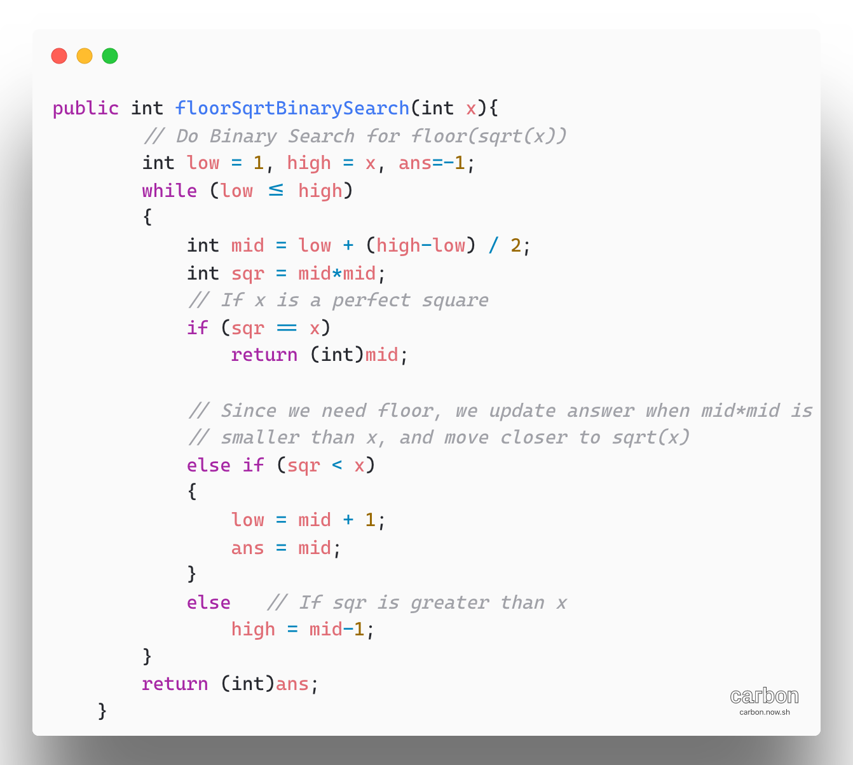

1. [Find the position of an element in a sorted array of infinite numbers](https://www.geeksforgeeks.org/find-position-element-sorted-array-infinite-numbers/)

If the array is infinite, that means we don’t have proper bounds to apply binary search. So in order to find position of key, first we find bounds and then apply binary search algorithm.  
Let low be pointing to 1st element and high pointing to 2nd element of array, Now compare key with high index element,   
->if it is greater than high index element then copy high index in low index and double the high index.   
->if it is smaller, then apply binary search on high and low indices found.

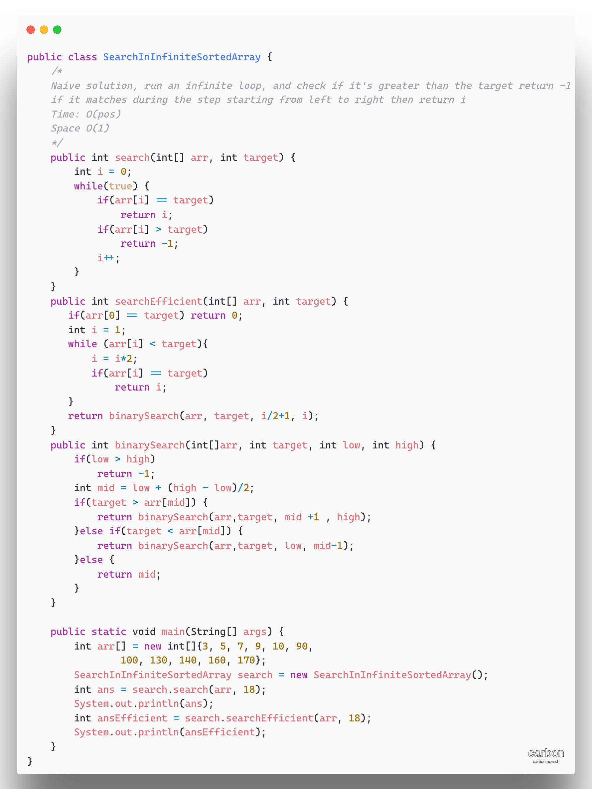

1. [Search in Rotated Sorted Array](https://leetcode.com/problems/search-in-rotated-sorted-array/)

The idea is that we add some additional condition checks in the normal binary search in order better narrow down the scope of the search

**Algorithm:**

As in the normal binary search, keep two pointers low, and high to track the search space. At each iteration, we reduce the search space into half by removing either the low or high pointer to the middle (i.e mid) of the previous scope.

Details break down of the algorithm:

* Initialize the pointer low = 0, and high = n-1
* Perform standard binary search, while (low < high)
  + Take index of mid as pivot
  + If nums[mid] == target return mid
  + Now there could be two situations
    - Pivot element is larger than the first element in the array i.e subarray from the first element to the pivot is non-rotated

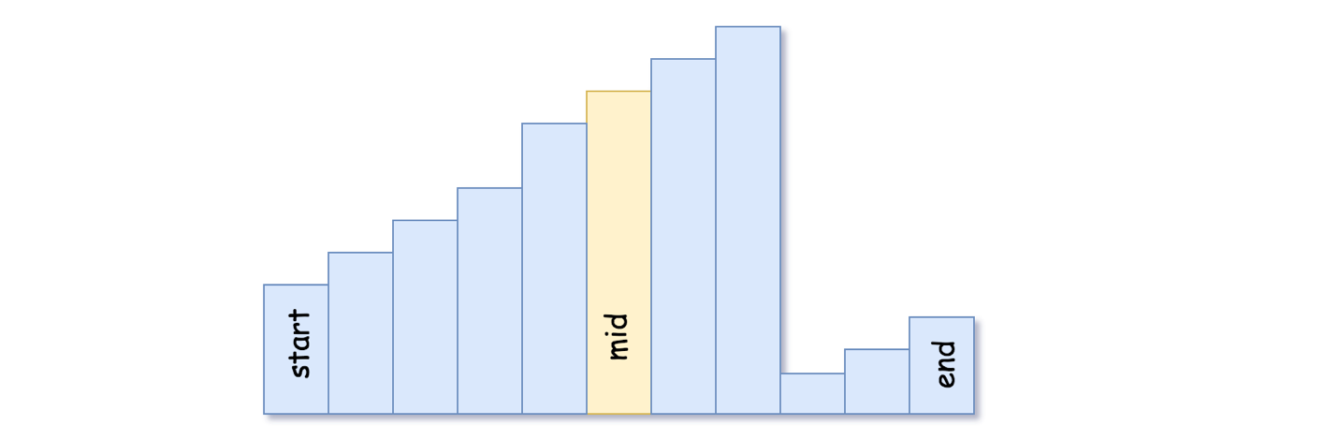

* If the target is located in the non -rotated subarray:

Go left: high = mid -1;

* Otherwise: go right: low = mid +1
* Pivot element is smaller than the first element of the array, i.e rotation index is somewhere between 0 and mid. It implies that sub-array from the pivot element to the last one is non rotated.

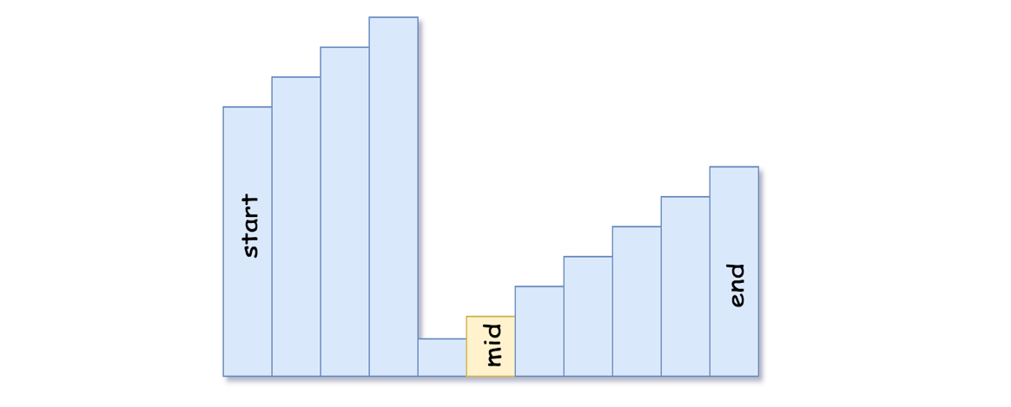

* If the target is located in the non-rotated subarray:

Go right: low = mid +1

* Otherwise: go left: high = mid -1
* We are here because the target is not found, return -1

Time complexity:

Time: O(nlogn)

Space: O(1)

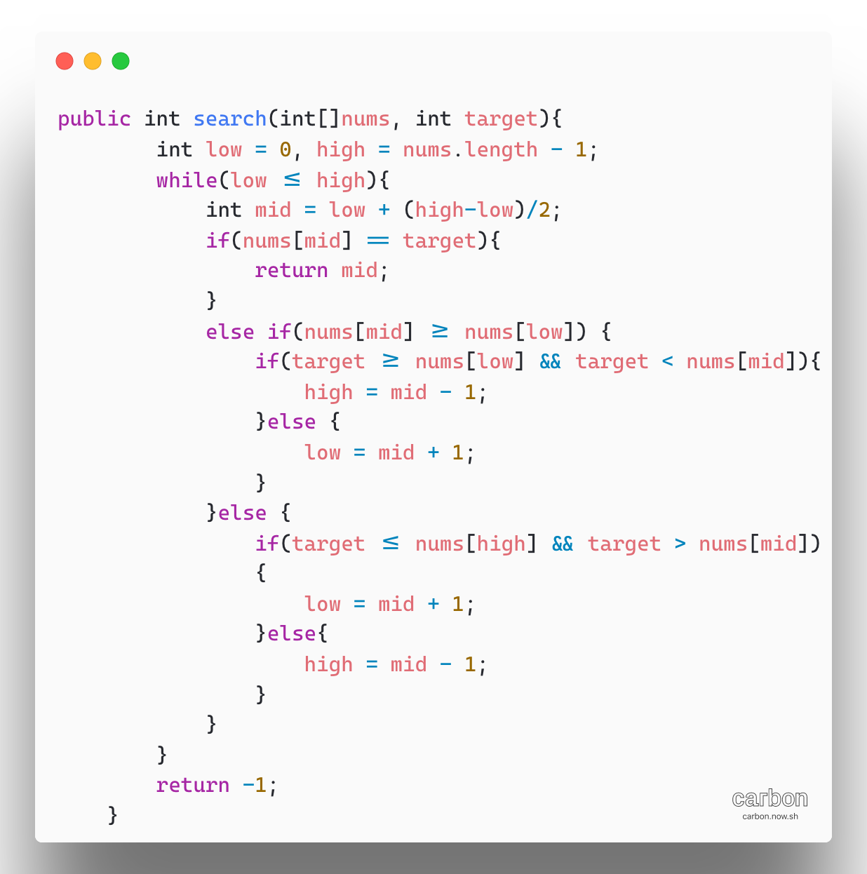

1. [Find a Peak Element](https://www.geeksforgeeks.org/find-a-peak-in-a-given-array/)

The idea based on binary search to check if the middle element is the peak element or not. If the middle element is not the peak element, then check if the element on the right side is greater than the middle element then there is always a peak element on the right side. If the element on the left side is greater than middle element then there is always a peak element on left side.

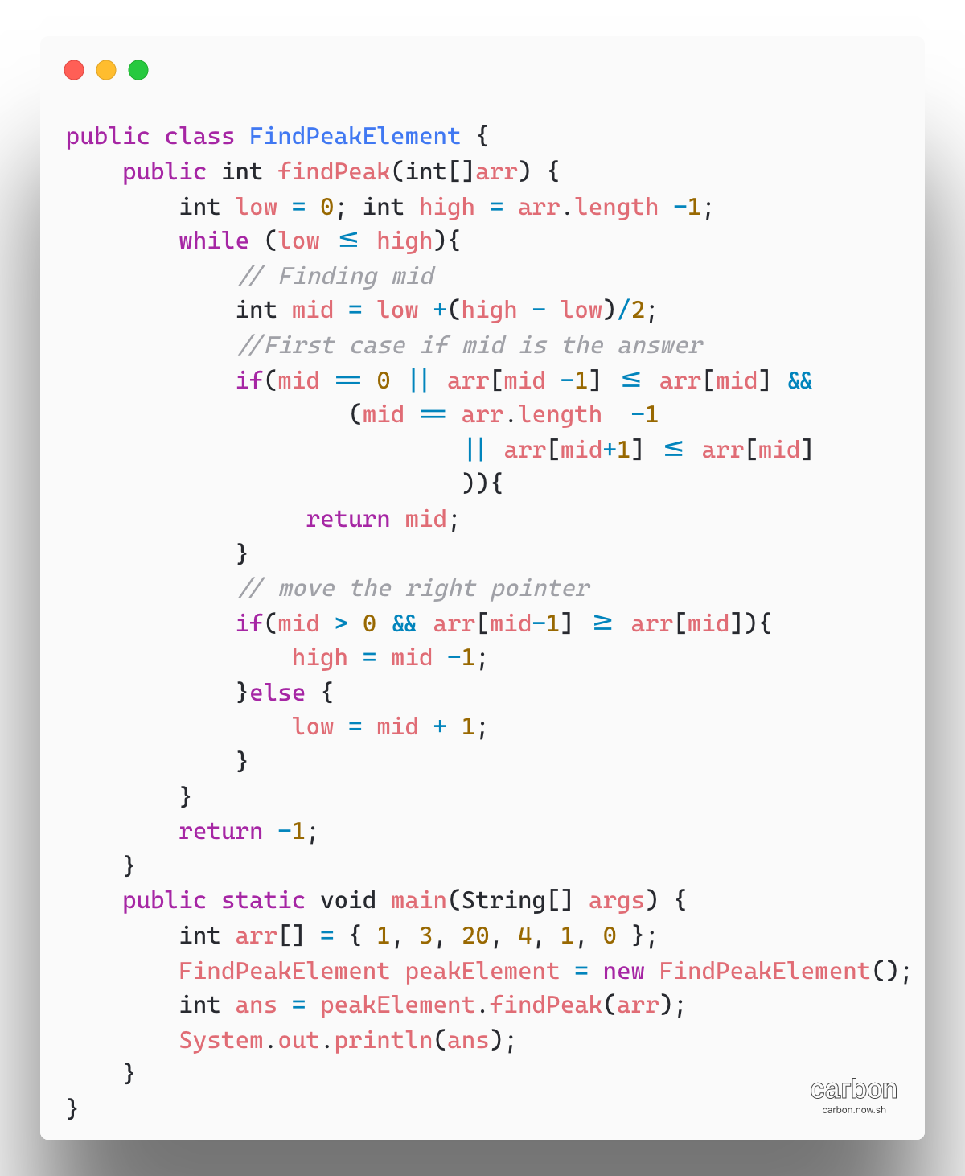

1. [Given an unsorted array and number x, we need to find if there is a pair in the array with sum equal to x. (Aka Two Sum)](https://leetcode.com/problems/two-sum/)

This can be solved using two pointer technique. But to use two pointer technique, the array must be sorted. Once the array is sorted the two pointers can be take which mark the beginning and end of the array respectively. If the sum is greater than the sum of those two elements, shift the right pointers can be to decrease the value of the required sum and if the sum is lesser than the required value, shift the left pointer to increase the value of the required sum.

Note: if there is more than one pair having the given sum then this algorithm reports only one.

**Algorithm:**

* Sort the array in non-decreasing order.
* Initialize two variables left = 0 and right = arr.length -1
* Loop while(left<right)
* If(arr[left] + arr[right] == sum) return true
* Else if(arr[left] + arr[right] < sum) then left++;
* Else right --;

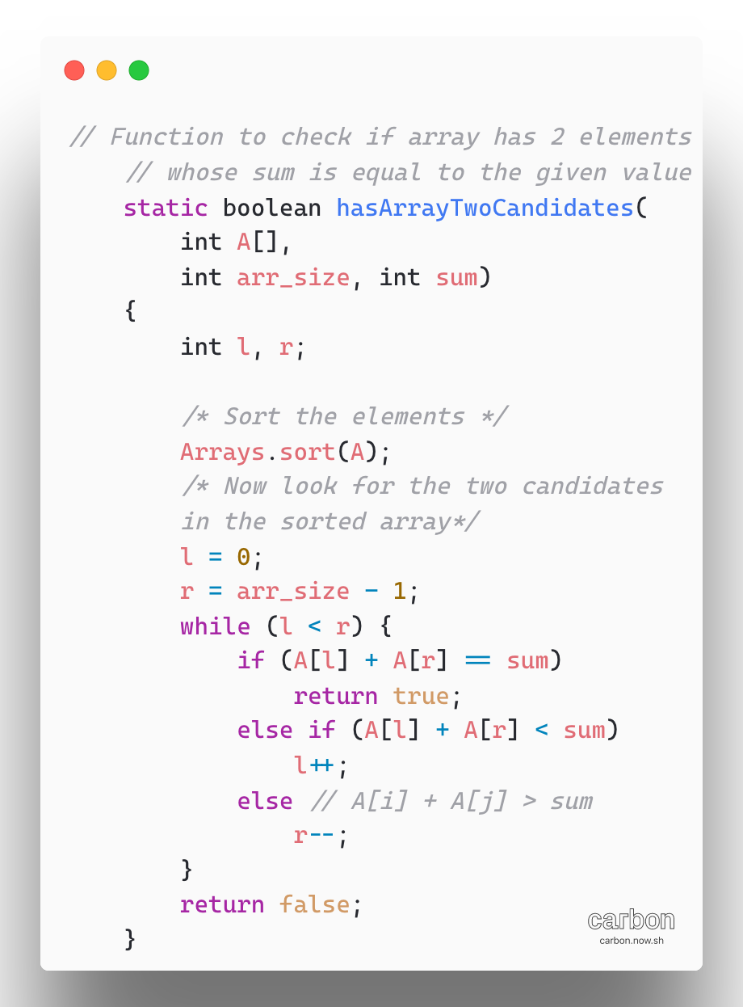

Note: In our case, we got unsorted array.

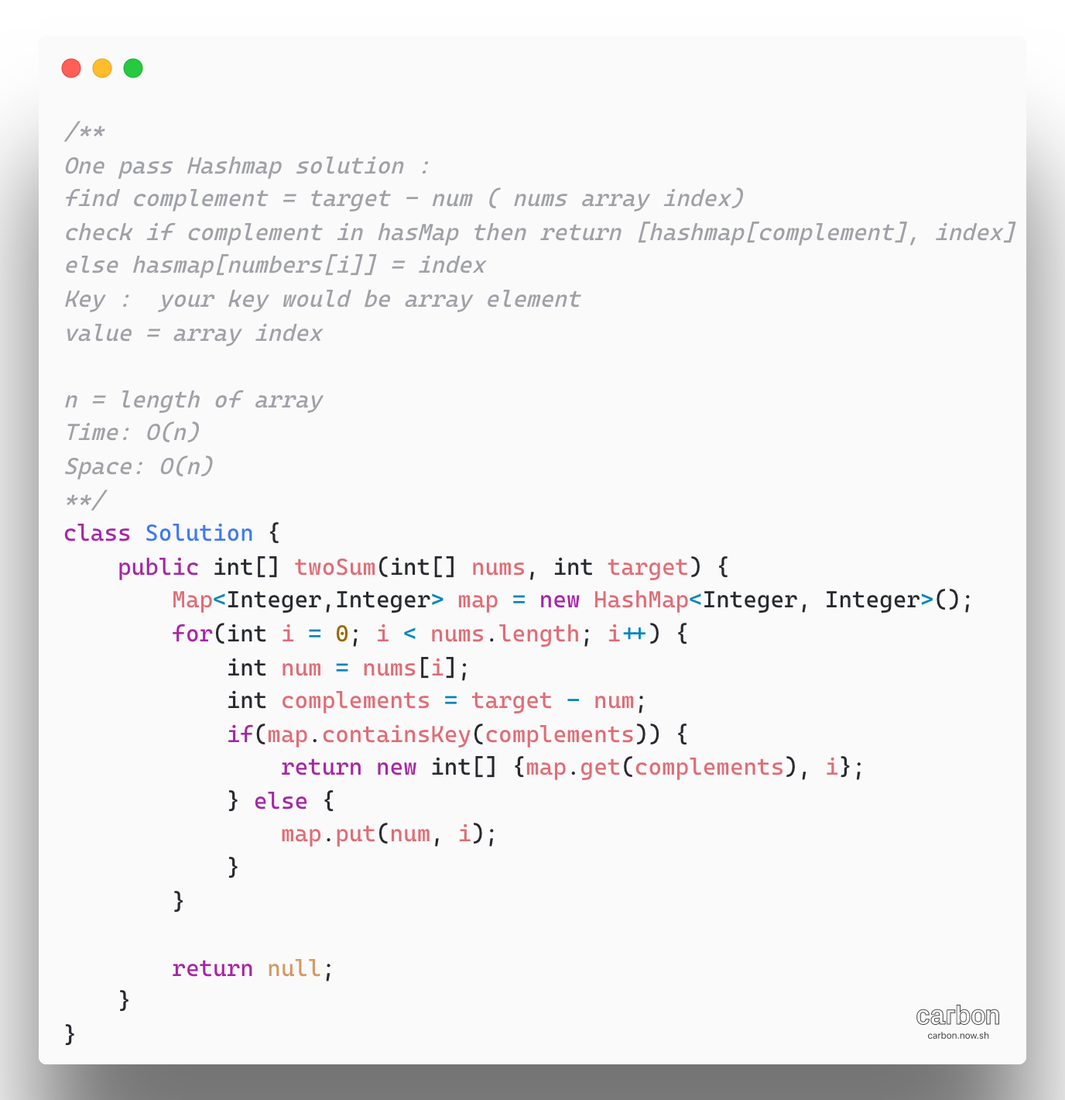

1. [Given an array and a sum if there is a triplet with given sum (3 Sum)](https://leetcode.com/problems/3sum/)

**Approach:** By sorting the array the efficiency of the algorithm can be improved, the efficient approach uses the two-pointer technique.

Traverse the array and fix the first element of the triplet. Now use the two pointers algorithm to find if there is a pair whose sum is equal to x -arr[i].

**Algorithm:**

* + Sort the given array
  + Loop over the array and fix the first element of the possible triplet, arr[i]
  + Then fix two pointers, one at i+1 and other at n-1, and loop at the sum
  + If the sum is smaller than the required sum, increment left pointer
  + Else if the sum is bigger, decrease the right pointer to reduce the sum
  + Else, if the sum of the elements at two pointer is equal to given sum, then print triplet.

**Complexity:**

Time complexity: O(N^2).

Space Complexity: O (1).

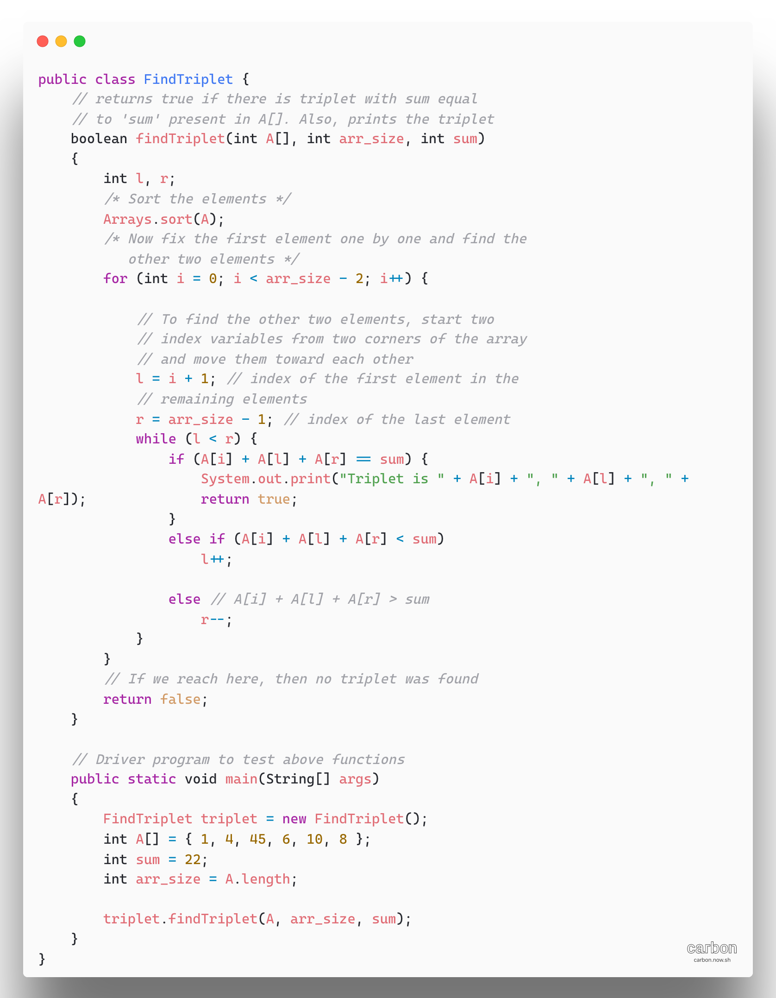

**Approach 3:** Hashing based solution.

This approach uses extra space, but it is simpler that the two pointers approach

Run two loops outer loop from start to end and inner loop from i+1 to end.

Create a hashmap or set to store the elements in between i+1 to j-1. So, if the given sum is x, check if there is a number in the set which is equal to x – arr[i]- arr[j], if yes then print triplet.

* + Traverse the array from start to end. (loop counter i)
  + Create a hashmap or set to store unique pairs
  + Run another loop from i + 1 to end of the array. (loop counter j)
  + If there is an element in the set which is equal to x-arr[i]-arr[j] then print the triplet (arr[i], arr[j], x – arr[i] – arr[j]) and break
  + Insert the jth element in the set

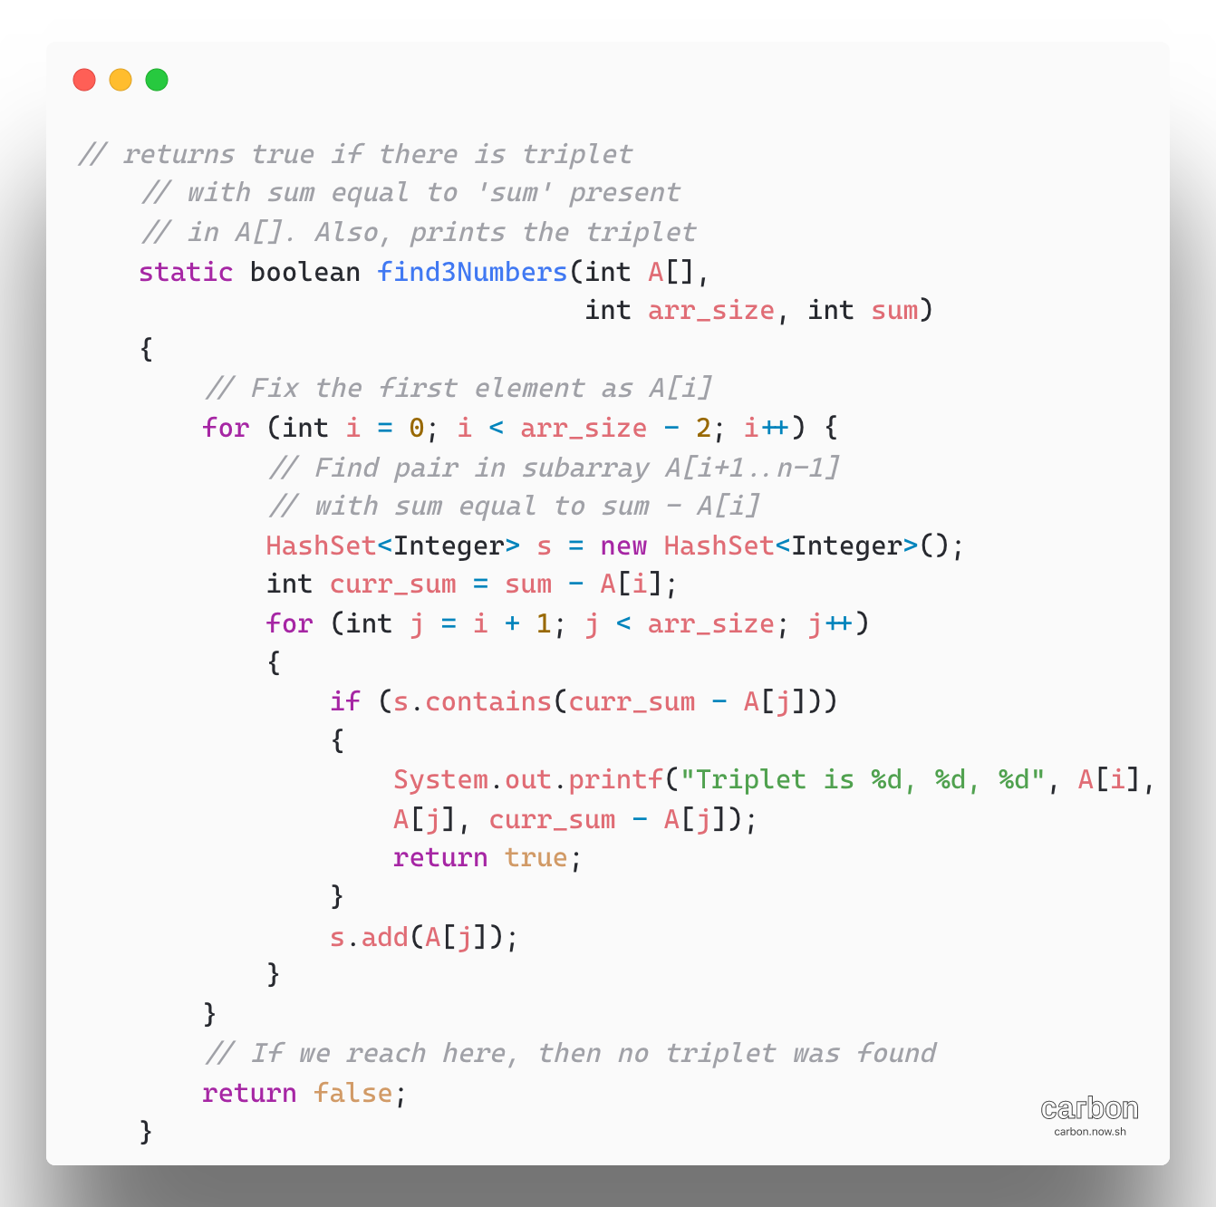

[Leetcode-3Sum](https://leetcode.com/problems/3sum/)

Refer: <https://www.youtube.com/watch?v=WdaeixEeAVs>

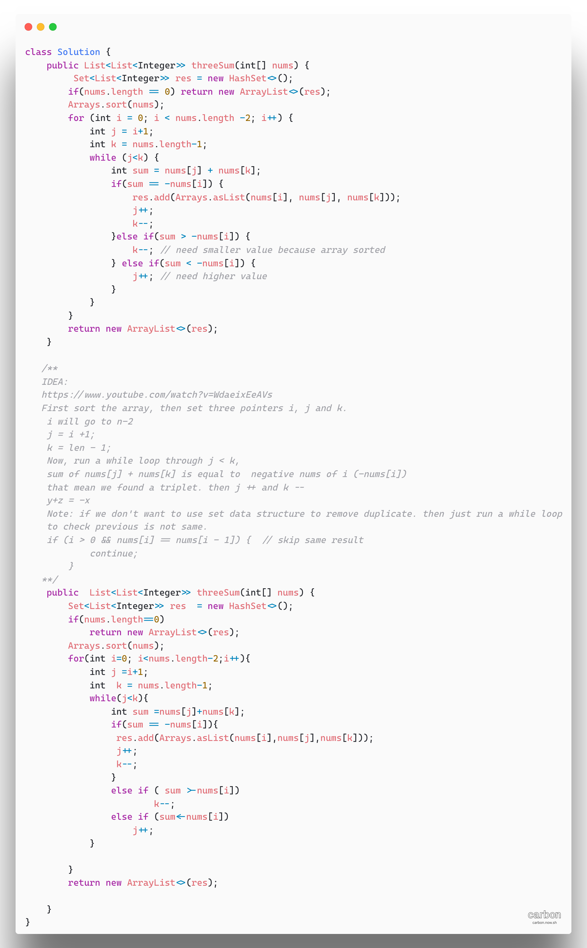

***VVIMP. Please don’t skip below problems.***

* + Count pairs with given sum
  + Count triplets with given sum
  + Find if there is triplet a, b, c such that a^2+b^2 = c^2

1. [3Sum Closest](https://leetcode.com/problems/3sum-closest/)

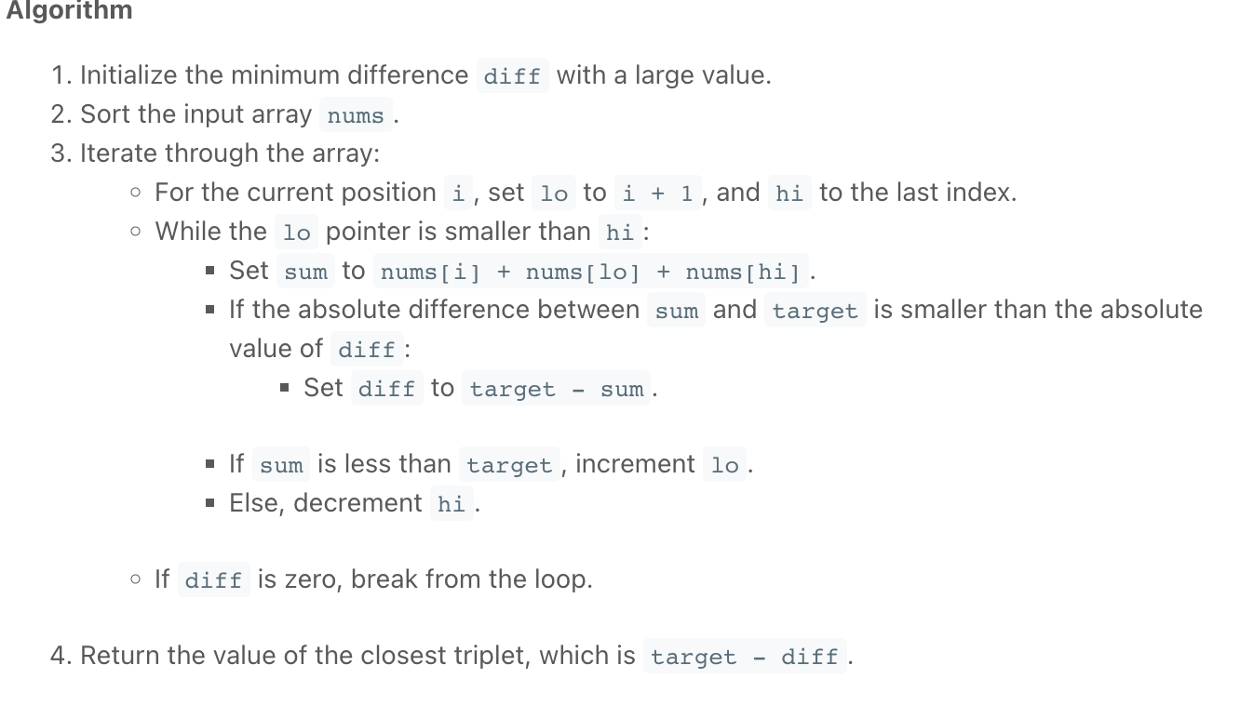

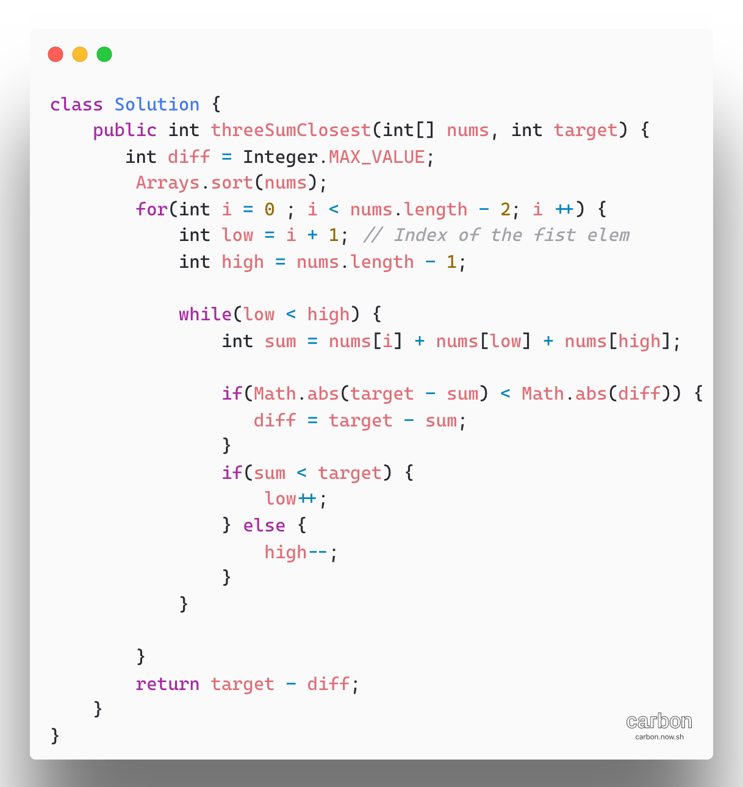

1. [3Sum Smaller](https://leetcode.com/problems/3sum-smaller/)

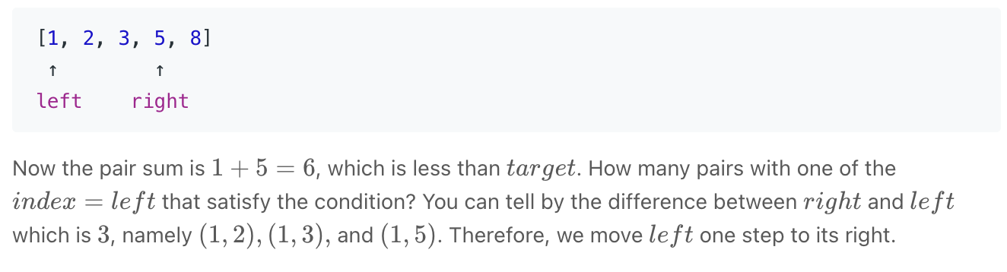

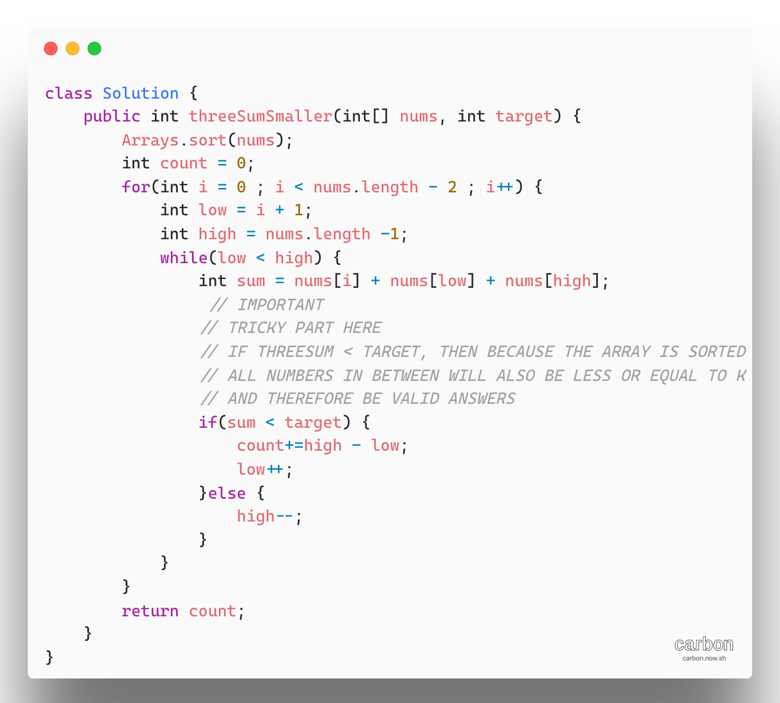

1. [**Median of Two sorted Array**](https://leetcode.com/problems/median-of-two-sorted-arrays/)

**Naïve:**

Time complexity O((n1+n2) * log(n1_n2))

* Create an array temp [] of size (n1+n2)
* Copy elements of a1[] and a2[] to temp[]
* Sort temp []
* If(n1+n2) is odd, then return middle of temp
* Else return average of middle two elements

**Approach**:

The given two arrays are sorted, we can utilize the ability of binary search to divide the array and find the median.

Median means the point at which the whole array is divide into two parts. Hence the two arrays are not merged so to get the median we require merging is costly. Hence instead of merging we will use below given algorithm to efficiently find median.

Refer: <https://www.youtube.com/watch?v=jDJuW7tSxio>

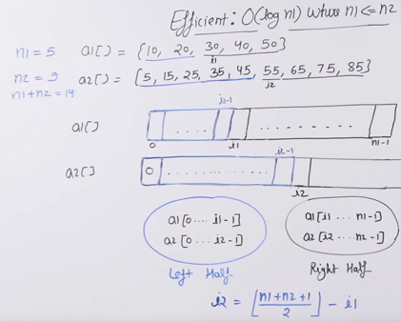

**Algorithm:**

* Let’s assume that there are two arrays A and B with array A having the minimum number of elements. If this is not the case then swap A and B to make A having small size.
* The edge cases like one array is empty or both are empty will be handled.
* let n be the size of A and m be the size of B.

Now think of an idea that if we have to find the median than we have to divide the whole merged array into two parts namely left and right parts.

Now since we are given the size of left part (i.e (n+m+1)/2), Now look at below given example.

A-> 1,2,3,4,5 n = 5

B-> 1,2,3,4,5,6 m = 6

Here merged array will look like :- 1,1,2,2,3,3,4,4,5,5,6 and median then is 3

Now we can see our left part which is underlined. We divide A and B into two parts such that the sum of left part of both A and B will result in left part of merged array.

A-> 1,2,3,4,5 // pointers l =0 and r = n-1 hence mid = (l+r)/2;

B -> 1,2,3,4,5,6

we can see that left part of A is given as n/2 and since total length of left part in merged array is (m+n+1)/2, so left part of B = (m+n+1)/2-n/2;

Now we just have to confirm if our left and right partitions in A and B are correct or not.

* Now we have 4 variables indicating four values two from array A and two from array B.

leftA -> Rightmost element in left part of A = 2

leftb -> Rightmost element in left part of B = 4

rightA -> Leftmost element in right part of A = 3

rightB -> Leftmost element in right part of B = 5

Hence to confirm that partition is correct we have to check the following conditions.

leftA<=rightB and leftB<=rightA // This is the case when the sum of two parts of A and B results in left part of merged array

if our partition not works that means we have to find other mid point in A and then left part in B

This is seen when

leftA > rightB //means we have to dec size of A's partition

so do r = mid-1;

else

do l =mid+1;

Hence repeat the above steps with new partitions till we get the answers.

* If leftA<=rightB and leftB<=rightA

then we get correct partition and our answer depends on the total size of merged array (i.e. m+n)

If (m+n)%2==0

ans is max(leftA,leftB)+min(rightA,rightB)/2; // max of left part is nearest to median and min of right part is nearest to median

else

ans is max(leftA,leftB);

**Time Complexity: O(min(log m, log n))**

**Space: O(1)**

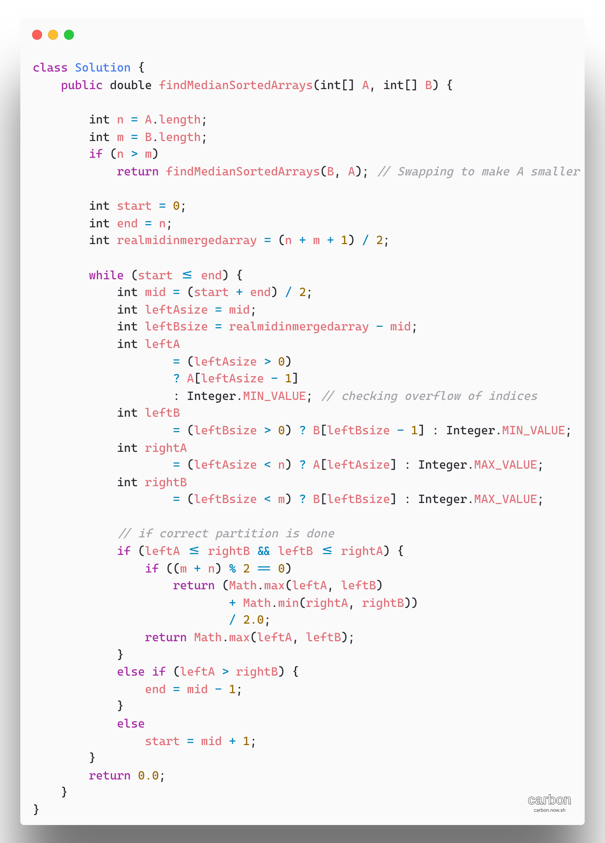

1. [Majority Element](https://leetcode.com/problems/majority-element/)

There is a brute force approach, The basic solution is to have two loops and keep track of the maximum count for all different elements. If the maximum count becomes greater than n/2, then break the loops and return the element having maximum count. If the maximum count does not more than n/2, then majority element does not exist.

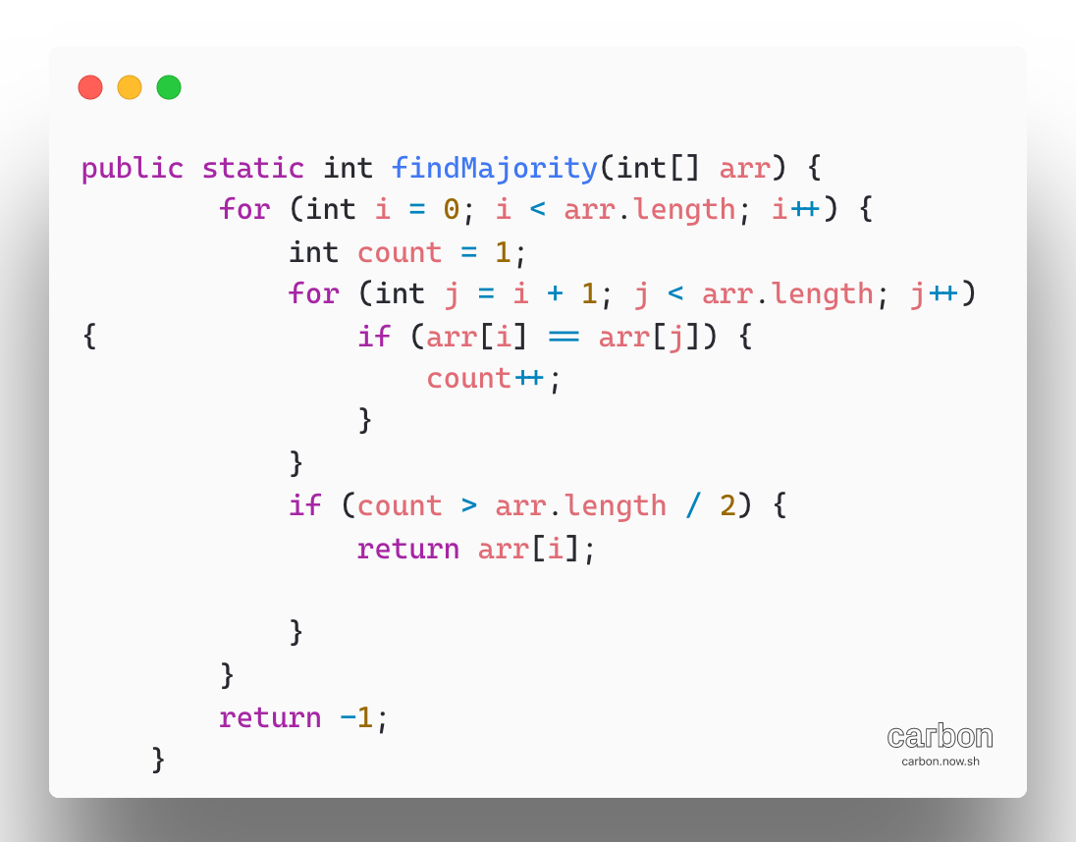

The above approach is n^2 solution.

**Approach2:** Insert elements in BST one by one and if an element is already present then increment the count of the node. At any stage, if the count of a node becomes more than n/2 then return.

**Algorithm:**

Create a binary search tree, if same element is entered in the binary search tree the frequency of the node is increased.

traverse the array and insert the element in the binary search tree.

If the maximum frequency of any node is greater than the half the size of the array, then perform a inorder traversal and find the node with frequency greater than half

Else print No majority Element.

**Complexity Analysis:**

**Time Complexity:** If a [Binary Search Tree](https://www.geeksforgeeks.org/binary-search-tree-set-1-search-and-insertion/) is used then time complexity will be O(n^2). If a [self-balancing-binary-search](http://en.wikipedia.org/wiki/Self-balancing_binary_search_tree) tree is used, then it will be O(nlogn)

**Auxiliary Space:**O(n).   
As extra space is needed to store the array in tree.

**METHOD 3 (Using Moore’s Voting Algorithm):**

**Approach: This is a two-step process.**

IDEA: O(n) solution using Moore voting  
Two Phase  
1) find out the majority  
2) Ensure its majority  
Note: Second phase is not needed if you are sure  
there is a majority element

**Algorithm:**

Loop through each element and maintains a count of majority element, and a majority index, maj_index

If the next element is same then increment the count if the next element is not same then decrement the count.

if the count reaches 0 then changes the maj_index to the current element and set the count again to 1.

Now again traverse through the array and find the count of majority element found.

If the count is greater than half the size of the array, print the element

Else print that there is no majority element

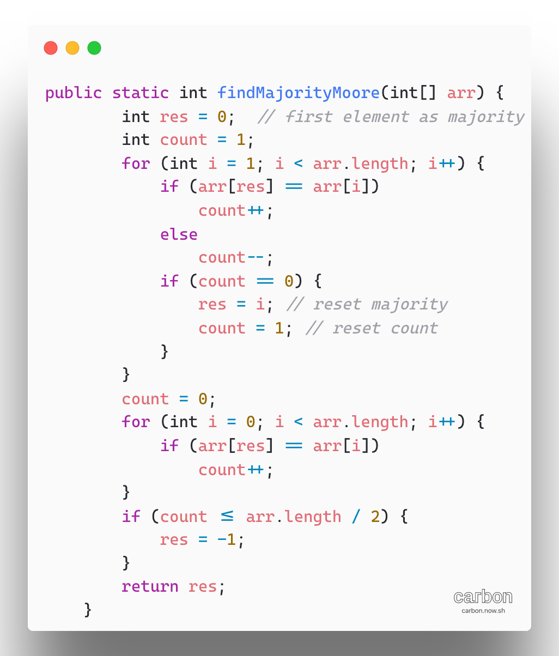

METHOD 4 (Using Hashmap):

Approach: This method is somewhat similar to Moore voting algorithm in terms of time complexity, but in this case, there is no need for the second step of Moore voting algorithm. But as usual, here space complexity becomes O(n).   
In Hashmap(key-value pair), at value, maintain a count for each element(key) and whenever the count is greater than half of the array length, return that key(majority element).

Complexity Analysis:

Time Complexity: O(n).   
One traversal of the array is needed, so the time complexity is linear.

Auxiliary Space: O(n).   
Since a hashmap requires linear space.

1. [Allocate minimum number of pages](https://www.geeksforgeeks.org/allocate-minimum-number-pages/)

***Note: There is a DP solution in gfg DP track***

IDEA: To use binary search, we fix a value for the number of pages as mod of current minimum and maximum.

We initialize minimum and maximum as 0 and sum- of- all-pages respectively. If a current mid can be a solution, then we search on the lower half, else we search in higher half.

Note the question arises, how to check if mid value is feasible or not ? Basically, we need to check if we can assign pages to all students in a way that the maximum number doesn’t exceed current value. To do this, we sequentially assign pages to every student while the current number of students becomes more than m, then the solution is not feasible. Else feasible

**Time Complexity:** O(N*log M), where N is the number of different books and M denotes the sum of number of pages of all different books  
**Auxiliary Space: O(1)**

